Record No: 0677
DOROTHY ALREWAS HESTER BELLINGHAM SOMERVILLE (Dorry)

2nd dau of Bellingham Arthur Somerville (0631) by his wife Margaret Hall Clinch (0632).

Birth: 15 Apr 1888, at Sea View, Wicklow
Bapt: 20 Apr 1889,at St Audoen’s Dublin
Death: 5 Mar 1895, at Sea View, Wicklow
Burial: 8 Mar 1895,at Wicklow churchyard

Source: Somerville Index

Additional notes:
David Gilmour remembers being told that the night BAS’ daughter died, a picture or a photograph fell off the mantel piece in the drawing room, said to be a superstition of an impending death. This is known generally in the family.

Dorry is believed to have died of typhoid.

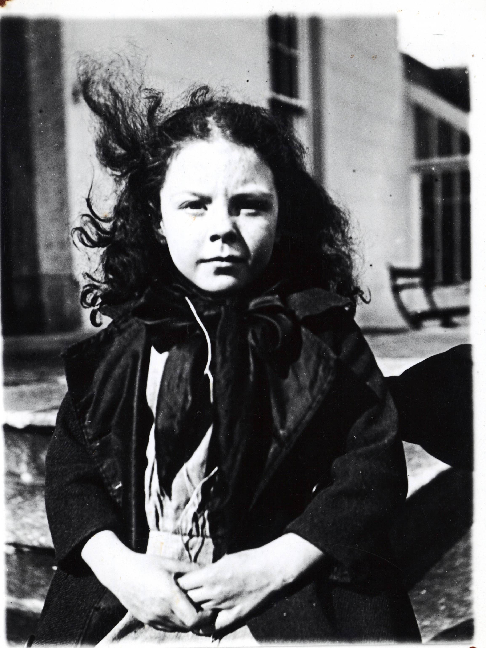
Dorry at Ballyhenry
15th April, 1894

